www.ecm-education.co.uk
Telephone: 07401 990093
Email: bookings@ecm-educationconsultants.co.uk

ECM Training Offer 2023/24
Face to Face & Online training

201

A message from the ECM Team……

Dear Colleagues,

Welcome to our new ECM Training Offer for the academic year 2023/24.

We are pleased to share our new plans for this new academic year. Our offer of support is based, as always, on the feedback gathered from our colleagues throughout the year and we have amended our provision to reflect this. We remain committed to providing the highest quality, up to date CPD and bespoke solutions that schools deserve. We have new courses and new training materials, as well as updated courses, that continue to reflect the continuously changing educational landscape.

Our ECM 2023/24 training will take place in two forms so that we can provide school leaders with the most flexible solutions to meet their varied needs.

The first will be Face-to-Face Training. It is our intention to be able to provide Face-to-Face sessions at local venues and schools as INSET days, staff meetings, cluster groups and local venues, just as we have done previously.
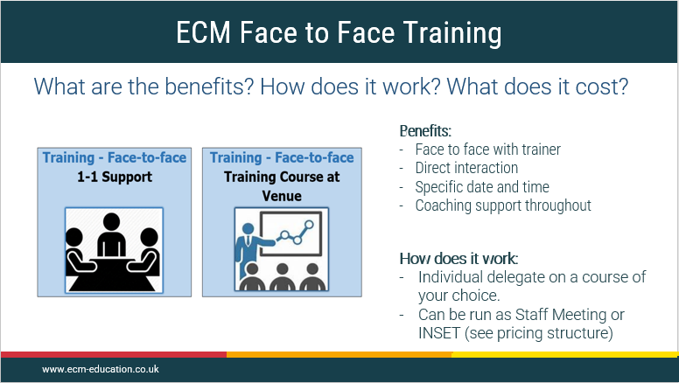

Secondly, we are delighted to be able to continue to offer our training Online Live. Feedback from colleagues this year has confirmed that schools are looking forward to Face-to-Face sessions but would also appreciate the flexibility that Online Live sessions bring. Dates for Face-to-Face and Online Live sessions can be found on our website.

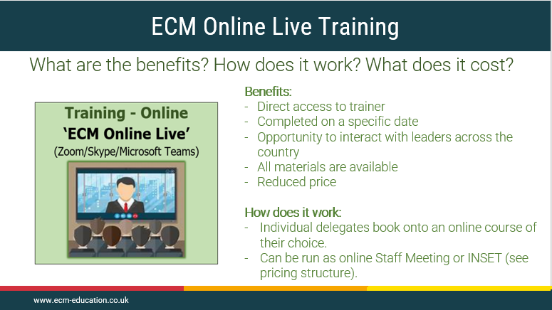

In addition to the provision of training through Face-to face and Online Live, we are very excited to continue to offer our training as a fully online downloadable service through our new and separate platform called SCHOOT (More details on next page). This will allow schools to fit in their CPD at any time on any day, allowing colleagues flexibility and work life balance. The same high quality ECM materials and training content will be available plus many more increased user-friendly additions requested by schools over the last 12 months.

As always, we would like to take this opportunity to thank you for your continued and unwavering support, it is very much appreciated.
Please don’t hesitate to get in touch if you have any further suggestions or ideas.
We look forward to seeing you at our training throughout the year, whether it be Face-to-Face or Online.

Best wishes
John, Phil and Mark
ECM Education

is our new platform and provider of online downloadable CPD. We have taken on board and learnt from our online experience over the last 12 months and have put together a more efficient and user-friendly platform to deliver a flexible and affordable CPD offer. There are added benefits of an online community and access to a wider range of materials and resources.

Benefits:

- Same high-quality training courses and content and materials from ECM.

- Up to date and regularly updated content relating to national initiatives.

- New materials and courses being added termly.

- Cost effective solution for school CPD

- Flexible and easy to use and access - the training can be completed in bitesize chunks by delegates

- Supports staff workload and well-being

- Easier to use platform with features such as:

- Personal CPD record.
- School and cluster/MAT overview of CPD accessed.
- Certificates for each course.

- Access to further resources and materials
- Network of and links to like-minded professionals to support colleagues – specific to areas of responsibility eg Headteachers or subject leaders…
- Voiceover commentary on each video clip takes delegates through the training course step by step
- Video clips are short, with a clear outcome or task at the end of each one
- Outcomes of the course are explicit- ‘Getting a Job Done’

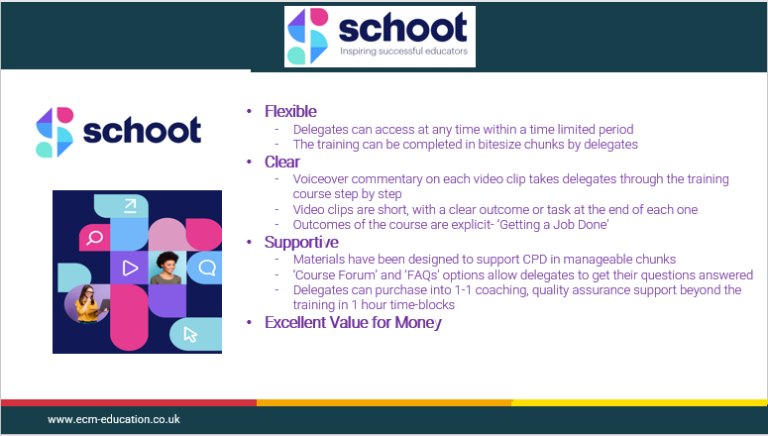

ECM Training Offer 2023/24
Contents

ECM Training Options 2023/24

Training - Face-to-face  1-1 support | Training - Face-to-face  Training course at a venue | Training - Online  ‘ECM Online Live’  (Zoom/Skype/Microsoft Teams)
What does this training look like?  - Delivered by ECM associates on school site or an alternative venue on an agreed date (up to 3 staff members).  - Delivered by ECM leadership partner on school site/alternative venue on an agreed date (up to 3 staff members). | What does this training look like?  - Delivered by ECM associates at a training venue on a defined date in a specific locality. Delegates book on the course individually.  - Training course repeated at different times of the year in a range of localities. Delegates book on the course individually.  - Delivered to groups of schools on agreed dates in different localities at a designated venue (usually costed at: up to 15 delegates per school) | What does this training look like?  - Delivered live by an ECM associate, at an agreed date and time through an online facility such as Zoom/Skype/Microsoft teams  - Delegates book on the course individually. ECM course leader admits pre-agreed delegates to the ’ECM Online Live’ training event or…  - ‘ECM Online Live’- delivered to groups of schools at an agreed date and time.
How do delegates access the training?  - Delegates sent a link to the ECM online training platform to access:  - the course training slides (time limited- 1 day)  - downloadable course materials for the 1-1 face to face training session | How do delegates access the training?  - Delegates sent a link to the ECM online training platform to access:  - the course training slides (time limited- 1 day)  - downloadable course materials for the face to face training course | How do delegates access the training?  - Delegates sent a link to the ECM online training platform to access:  - the course training slides (time limited- 1 day)  - downloadable course materials for the online live training course

Leadership & Management – Senior Leadership
Training Course Titles |  |  |  | *Options available for face to face and Live training.  Time2Train (T2T) & Full Day
 | FACE TO FACE  1-1 Support* | FACE TO FACE  Training Venue* | ECM  ONLINE  Live* | T2T  1 x 2 hr session | T2T  2 x 2 hr sessions | FULL DAY  6 hours
- Writing Your School Self-Evaluation Summary (SES) 23/24 | ü | ü | ü | û | ü | ü
- Writing Your School Impact/Development Plan (SIP/SDP) 23/24 - Demonstrating IMPACT | ü | ü | ü | û | ü | ü
- Monitoring & Evaluation for Maximum IMPACT – including a ‘Deep Dive’ Approach | ü | ü | ü | û | ü | ü
- Monitoring and Evaluation: Leading People; Securing Improvement | ü | ü | ü | û | ü | ü
- Monitoring & Evaluation: Learning Walks, Workbooks and the Pupil Voice | ü | ü | ü | û | ü | ü

- Leaders can purchase coaching/ mentoring/ quality assurance time with an ECM Associate of their choice to follow up from any of the training courses. (see ECM Price Guide or contact bookings@ecm-educationconsultants.co.uk for more information).

Training Course Titles |  |  |  | *Options available for face to face and Live training.  Time2Train (T2T) & Full Day
 | FACE TO FACE  1-1 Support* | FACE TO FACE  Training Venue*  (at request) | ECM  ONLINE  Live* | T2T  1 x 2 hr session | T2T  2 x 2 hr sessions | FULL DAY  6 hours
- Work Scrutiny - Evidencing IMPACT (from the 3Is) in the Inspection Framework | ü | ü | ü | ü | û | û
- Appraisal of Teachers: Ensuring Support, Consistency & Rigour | û | û | ü | ü | û | û
- Appraisal of Teaching Assistants: Ensuring Consistency and Rigour in the Inspection Framework | û | û | ü | ü | û | û
Leadership & Management - Senior Leadership
Leadership & Management - Senior Leadership

- Leaders can purchase coaching/ mentoring/ quality assurance time with an ECM Associate of their choice to follow up from any of the training courses. (see ECM Price Guide or contact bookings@ecm-educationconsultants.co.uk for more information).

Leadership & Management – Senior and Middle Leaders
Training Course Titles |  |  |  | *Options available for face to face and Live training.  Time2Train (T2T) & Full Day
 | FACE TO FACE  1-1 Support* | FACE TO FACE  Training Venue*  (at request) | ECM  ONLINE  Live* | T2T  1 x 2 hr session | T2T  2 x 2 hr sessions | FULL DAY  6 hours
- A Deep Dive into Reading & phonics– English Leaders/ Headteachers/ Senior Leaders | ü | ü | ü | ü | û | û
- A Deep Dive into Maths – Maths leaders/ Headteachers/ Senior Leaders | ü | ü | ü | ü | û | û
- A Deep Dive into Science – Science leaders/ Headteachers/ Senior Leaders | ü | ü | ü | ü | û | û
- A Deep Dive into History –History leaders/ Headteachers/ Senior Leaders | ü | ü | ü | ü | û | û
- A Deep Dive into Geography – Geography leaders/ Headteachers/ Senior Leaders | ü | ü | ü | ü | û | û
- A Deep Dive into Design and Technology – D&T leaders/ Headteachers/ Senior Leaders | ü | ü | ü | ü | û | û
- A Deep Dive into PE – PE leaders/ Headteachers/ Senior Leaders | ü | ü | ü | ü | û | û
- A Deep Dive into Art –Art leaders/ Headteachers/ Senior Leaders | ü | ü | ü | ü | û | û
- A Deep Dive into Computing – Computing leaders/ Headteachers/ Senior Leaders | ü | ü | ü | ü | û | û
- A Deep Dive into Music – Music leaders/ Headteachers/ Senior Leaders | ü | ü | ü | ü | û | û
- A Deep Dive into PSHE & Citizenship– PSHE & Citizenship leaders/ Headteachers/ Senior Leaders | ü | ü | ü | ü | û | û
- A Deep Dive into Languages – Languages leaders/ Headteachers/ Senior Leaders | ü | ü | ü | ü | û | û
- A Deep Dive into SEND  SEND leaders/ Headteachers/  Senior Leaders | ü | ü | ü | ü | û | û
- An introduction to Deep Dives – non subject specific | ü | ü | ü | ü

Leadership & Management – Senior & Middle Leaders
Training Course Titles |  |  |  | *Options available for face to face and Live training.  Time2Train (T2T) & Full Day
 | FACE TO FACE  1-1 Support* | FACE TO FACE  Training Venue*  (at request) | ECM  ONLINE  Live* | T2T  1 x 2 hr session | T2T  2 x 2 hr sessions | FULL DAY  6 hours
- Ensuring Strong curriculum subject knowledge for middle /subject leaders in each curriculum area (a separate course for each curriculum subject – English, Maths, Science, History, D&T, Art, Geography, PE, RE, Music, Languages and Computing) | ü | ü | ü | ü | û | û
- Ensure your subject curriculum INTENT is high quality and will stand up to inspection scrutiny | ü | ü | ü | û | û | Half day (3 hours)
- Monitoring for Impact from intent and implementation to impact | ü | ü | ü | ü | û | û
- Outstanding subject leadership 5: Giving strong account for your subject: English- Creating a summary PowerPoint using latest inspection methodology to present to head teachers/ governors and inspectors. | ü | ü | ü | û | û | Half day (3 hours)
- Outstanding subject leadership 5: Giving strong account for your subject: Maths- Creating a summary PowerPoint using latest inspection methodology to present to head teachers/ governors and inspectors. | ü | ü | ü | û | û | Half day (3 hours)
- Outstanding subject leadership 5: Giving strong account for your subject: Science- Creating a summary PowerPoint using latest inspection methodology to present to head teachers/ governors and inspectors. | ü | ü | ü | û | û | Half day (3 hours)
- Outstanding subject leadership 5: Giving strong account for your subject: History- Creating a summary PowerPoint using latest inspection methodology to present to head teachers/ governors and inspectors. | ü | ü | ü | û | û | Half day (3 hours)
- Outstanding subject leadership 5: Giving strong account for your subject: Geography- Creating a summary PowerPoint using latest inspection methodology to present to head teachers/ governors and inspectors. | ü | ü | ü | û | û | Half day (3 hours)
- Outstanding subject leadership 5: Giving strong account for your subject: Art- Creating a summary PowerPoint using latest inspection methodology to present to head teachers/ governors and inspectors. | ü | ü | ü | û | û | Half day (3 hours)
- Outstanding subject leadership 5: Giving strong account for your subject: Music- Creating a summary PowerPoint using latest inspection methodology to present to head teachers/ governors and inspectors. | ü | ü | ü | û | û | Half day (3 hours)
- Outstanding subject leadership 5: Giving strong account for your subject: PSHE/Citizenship Creating a summary PowerPoint using latest inspection methodology to present to head teachers/ governors and inspectors. | ü | ü | ü | û | û | Half day (3 hours)
- Outstanding subject leadership 5: Giving strong account for your subject: RE -Creating a summary PowerPoint using latest inspection methodology to present to head teachers/ governors and inspectors. | ü | ü | ü | û | û | Half day (3 hours)
- Outstanding subject leadership 5: Giving strong account for your subject: PE- Creating a summary PowerPoint using latest inspection methodology to present to head teachers/ governors and inspectors. | ü | ü | ü | û | û | Half day (3 hours)
- Outstanding subject leadership 5: Giving strong account for your subject: Computing- Creating a summary PowerPoint using latest inspection methodology to present to head teachers/ governors and inspectors. | ü | ü | ü | û | û | Half day (3 hours)
- Outstanding subject leadership 5: Giving strong account for your subject: Languages- Creating a summary PowerPoint using latest inspection methodology to present to head teachers/ governors and inspectors. | ü | ü | ü | û | û | Half day (3 hours)
- Outstanding subject leadership 5: Giving strong account for your subject: D&T- Creating a summary PowerPoint using latest inspection methodology to present to head teachers/ governors and inspectors. | ü | ü | ü | û | û | Half day (3 hours)

Leadership & Management - Middle Leaders
Training Course Titles |  |  |  | *Options available for face to face and Live training.  Time2Train (T2T) & Full Day
 | FACE TO FACE  1-1 Support* | FACE TO FACE  Training Venue*  (at request) | ECM  ONLINE  Live* | T2T  1 x 2 hr session | T2T  2 x 2 hr sessions | FULL DAY  6 hours
- Outstanding subject leadership 1: The Role of the Subject Leader | ü | ü | ü | û | ü | ü
- Outstanding subject leadership 2: Securing robust subject Self-Evaluation and development planning in the NEW Inspection | ü | ü | ü | û | ü | ü
- Outstanding subject leadership 3: Monitoring & Evaluation to drive improvement in your subject. | ü | ü | ü | û | ü | ü
- Outstanding subject leadership 4: Improving outcomes in your subject through Training, Coaching, Modelling and Mentoring | ü | ü | û | û | ü | ü
- Outstanding subject leadership 6: How to be a great subject leader (for RQTs, NQTs and those new to subject leadership) | ü | ü | ü | û | ü | ü

Curriculum, Learning & Teaching
Training Course Titles |  |  |  | *Options available for face to face and Live training.  Time2Train (T2T) & Full Day
 | FACE TO FACE 1-1 Support* | FACE TO FACE  Training Venue*  (at request) | ECM  ONLINE  Live* | T2T  1 x 2 hr session | T2T  2 x 2 hr sessions | FULL DAY  6 hours
- Year 6 – achieving outstanding outcomes | û | û | ü | û | û | ü
- Year 2 – achieving outstanding outcomes | û | û | ü | û | û | ü
- Coaching for Excellence - Maximising the potential of teachers in the classroom - Lead Practitioner Training | û | û | ü | û | ü | û
- Memory, sticky learning, cognitive load and dual coding- what curriculum leaders need to know.  What Senior leaders need to know | ü | ü | ü | û | ü | ü
- Teaching to improve memory, building knowledge using cognitive load theory - practical solutions for subject leaders and class teachers. | ü | ü | ü | û | ü | ü
- Ensuring progression in vocabulary and concepts in foundation subjects | ü | ü | ü | ü | û | û
- Improving Memory, Stickability & Powerful pedagogy: securing Pupils’ Long Term Memory | û | û | ü | û | û | ü
- Metacognition – Developing learner independence to secure better/improved outcomes | û | û | ü | û | û | ü
- Art – Progression of knowledge and skills (being inspection ready, drawing focus, painting focus, printing focus, 3D focus and textiles and collage focus) | û | û | ü | ü | û | û
- Rosenshine’s Principles and Questioning | û | û | ü | ü | û | û

- Leaders can purchase coaching/ mentoring/ quality assurance time with an ECM Associate of their choice to follow up from any of the training courses. (see ECM Price Guide or contact bookings@ecm-educationconsultants.co.uk for more information).

Science
Training Course Titles |  |  |  | *Options available for face to face and Live training.  Time2Train (T2T) & Full Day
 | FACE TO FACE 1-1 Support* | FACE TO FACE  Training Venue*  (at request) | ECM  ONLINE  Live* | T2T  1 x 2 hr session | T2T  2 x 2 hr sessions | FULL DAY  6 hours
- Developing effective leadership skills in science in readiness for inspection in the new framework | ü | ü | ü | û | ü | ü
- Learning science outside the classroom | ü | ü | ü | ü | û | û
- A Deep Dive into Science – Science leaders/ Head teachers / Senior Leaders | ü | ü | ü | ü | û | û
- Leaders can purchase coaching/ mentoring/ quality assurance time with an ECM Associate of their choice to follow up from any of the training courses. (see ECM Price Guide or contact bookings@ecm-educationconsultants.co.uk for more information).

ECM Termly Briefings
Training Course Titles |  |  |  | *Options available for face to face and Live training.  Time2Train (T2T) & Full Day
 | FACE TO FACE  1-1 Support* | FACE TO FACE  Training Venue can be requested | ECM  ONLINE Live* | T2T  1 x 2 hr session | T2T  2 x 2 hr sessions | FULL DAY  6 hours
- Headteacher, Deputy Headteacher and Senior Leader Termly Briefings | ü | ü | ü | ü | û | û
- English Termly Briefings | ü | ü | ü | ü | û | û
- Maths Termly Briefings | ü | ü | ü | ü | û | û
- Science Termly Briefings | ü | ü | ü | ü | û | û

Assessment
Training Course Titles |  |  |  | *Options available for face to face and Live training.  Time2Train (T2T) & Full Day
 | FACE TO FACE 1-1 Support* | FACE TO FACE  Training Venue*  (at request) | ECM  ONLINE Live* | T2T  1 x 2 hr session | T2T  2 x 2 hr sessions | FULL DAY  6 hours
- Assessment in Foundation Subjects - Being Inspection Ready | ü | ü | ü | ü | û | û
- Assessment without assessments | ü | ü | ü | û | û | ü
- Understanding and Analysing your IDSR ready for inspection – including new progress measures | ü | ü | ü | û | û | ü

- Leaders can purchase coaching/ mentoring/ quality assurance time with an ECM Associate of their choice to follow up from any of the training courses. (see ECM Price Guide or contact bookings@ecm-educationconsultants.co.uk for more information).

Early Years
Training Course Titles |  |  |  | *Options available for face to face and Live training.  Time2Train (T2T) & Full Day
 | FACE TO FACE 1-1 Support* | FACE TO FACE  Training Venue*  (at request) | ECM  ONLINE  Live* | T2T  1 x 2 hr session | T2T  2 x 2 hr sessions | FULL DAY  6 hours
- Using the Ofsted framework to evaluate your Early Years provision | ü | ü | ü | û | û | ü
- Writing your Early Years Self Evaluation Summary (SES) | ü | ü | ü | û | û | 3 hrs
- Writing your Early Years Impact Plan (SIP) | ü | ü | ü | û | û | 3 hrs
- Speech & language support in the Early Years | ü | ü | ü | û | û | ü
- Outdoor provision: high quality teaching & learning in the Early Years | ü | ü | ü | û | û | ü
- Supporting a smooth transition from EYFS-Y1 | ü | ü | ü | û | û | ü
- Supporting Inclusion in the Early Years | ü | ü | ü | û | û | 3 hrs
- Early Years Network Briefings | û | û | ü | û | û | 1 hour
- Maths in the Early Years | ü | ü | ü | û | û | ü
- Literacy in the Early Years | ü | ü | ü | û | û | ü

SEND/PUPIL PREMIUM
Training Course Titles |  |  |  | *Options available for face to face and Live training.  Time2Train (T2T) & Full Day
 | FACE TO FACE  1-1 Support* | FACE TO FACE  Training Venue*  (at request) | ECM  ONLINE  Live* | T2T  1 x 2 hr session | T2T  2 x 2 hr sessions | FULL DAY  6 hours
- Disadvantaged Pupils: Raising outcomes and Tackling Educational Disadvantage. | ü | ü | ü | û | ü | ü
- Securing great outcomes from starting points for SEND pupils- Senior Leaders & SENCos | ü | ü | ü | ü | û | û
- Working with SEND Pupils- Securing great outcomes from starting points for SEND pupils for Teachers & Teaching Assistants | ü | ü | ü | ü | û | û
- A Deep Dive into SEND– SENCO leaders/ Headteachers/ Senior Leaders | ü | ü | ü | ü | û | û

- Leaders can purchase coaching/ mentoring/ quality assurance time with an ECM Associate of their choice to follow up from any of the training courses. (see ECM Price Guide or contact bookings@ecm-educationconsultants.co.uk for more information).
/ Ofsted

Inspection/Ofsted
Training Course Titles |  |  |  | *Options available for face to face and Live training.  Time2Train (T2T) & Full Day
 | FACE TO FACE  1-1 Support* | FACE TO FACE  Training Venue*  (at request) | ECM  ONLINE  Live* | T2T  1 x 2 hr session | T2T  2 x 2 hr sessions | FULL DAY  6 hours
- Inspection Skills - 1 day- Headteachers, Senior leaders | û | û | ü | û | û | ü
- From inspection call to inspection report- being prepared Headteachers, Senior leaders (Updated in light of COVID) | ü | ü | ü | û | û | ü
- Good to great learning – a research and self-evaluation led approach (formerly Securing a good/outstanding judgement)- Headteachers, senior leaders | ü | ü | ü | û | û | ü
- Deep dives in foundation subjects- Separate for each subject- Subject leaders- see page 6 | ü | ü | ü | ü | û | û

- Leaders can purchase coaching/ mentoring/ quality assurance time with an ECM Associate of their choice to follow up from any of the training courses. (see ECM Price Guide or contact bookings@ecm-educationconsultants.co.uk for more information).

Secondary
Training Course Titles |  |  |  | *Options available for face to face and Live training.  Time2Train (T2T) & Full Day
 | FACE TO FACE  1-1 Support* | FACE TO FACE  Training Venue*  (at request) | ECM  ONLINE  Live* | T2T  1 x 2 hr session | T2T  2 x 2 hr sessions | FULL DAY  6 hours
- Writing Your Secondary School Self-Evaluation Summary (SES) 2023/24 | ü | ü | ü | û | ü | ü
- Writing your Secondary School Impact/Development Plan (SIP/SDP) 2023/24- Demonstrating IMPACT | ü | ü | ü | û | ü | ü
- Monitoring & Evaluation for Maximum IMPACT – including a ‘Deep Dive’ Approach | ü | ü | ü | û | ü | ü
- Monitoring and Evaluation: Leading People; Securing Improvement | ü | ü | ü | û | ü | ü
- Appraisal of Teachers: Ensuring Support, Consistency & Rigour | ü | ü | ü | ü | û | û
- Appraisal of Teaching Assistants: Ensuring Consistency and Rigour in the Inspection Framework | û | û | ü | ü | û | û
- Outstanding Subject Leadership 1: The Role of the Subject Leader | û | û | ü | û | ü | ü
- Outstanding Subject Leadership 2: Securing robust subject Self-Evaluation and development planning using the inspection framework | ü | ü | ü | û | ü | ü
- Outstanding Subject Leadership 3: Monitoring & Evaluation to drive improvement in your subject. | û | û | ü | û | ü | ü
- Outstanding Subject Leadership 4: Improving outcomes in your subject through Training, Coaching, Modelling and Mentoring | û | û | ü | û | ü | ü
- Outstanding Subject Leadership 5: How to be a great subject leader (for RQTs, NQTs and those new to subject leadership) | û | û | ü | û | ü | ü
- Using metacognition to motivate and develop student independence in secondary schools | û | û | ü | ü | û | û
- Work Scrutiny: Evidencing IMPACT (from the 3Is) in the Inspection Framework for Secondary | ü | ü | ü | ü | û | û
- Improving Memory, Stickability & Powerful pedagogy: securing Pupils’ Long Term Memory | û | û | ü | û | û | ü
15. Metacognition - Developing learner independence to secure better / improved outcomes. | û | û | ü | û | û | ü

- Leaders can purchase coaching/ mentoring/ quality assurance time with an ECM Associate of their choice to follow up from any of the training courses. (see ECM Price Guide or contact bookings@ecm-educationconsultants.co.uk for more information).

Governors
Training Course Titles |  |  |  | *Options available for face to face and Live training.  Time2Train (T2T) & Full Day
 | FACE TO FACE  1-1 Support* | FACE TO FACE  Training Venue*  (at request) | ECM  ONLINE  Live* | T2T  1 x 2 hr session | T2T  2 x 2 hr sessions | FULL DAY  6 hours
- School Self-Evaluation - Securing Governor Involvement | û | û | ü | ü | û | û
- Strategic Impact/Development Planning - Securing Governor Involvement | û | û | ü | ü | û | û
- Ofsted Framework - What does it mean for Governors? | û | û | ü | ü | û | û
- Securing the Role of the Governor in Monitoring School Performance | û | û | ü | ü | û | û
- Becoming an effective Subject Link Governor | û | û | ü | ü | û | û
- Disadvantaged Pupils - Securing Impact and Diminishing Difference - What Governors Need to Know | û | û | ü | ü | û | û
- Roles and Responsibilities of Governors | û | û | ü | ü | û | û
- Highly Effective Governing Boards - Considering Best Practice | û | û | ü | ü | û | û
- New to Governance | û | û | ü | ü | û | û
- Performance Management and Appraisal Process - What Governors need to know | û | û | ü | ü | û | û
- Does our school curriculum meet Ofsted requirements and how do I know as a Governor? | û | û | ü | ü | û | û

- Leaders can purchase coaching/ mentoring/ quality assurance time with an ECM Associate of their choice to follow up from any of the training courses. (see ECM Price Guide or contact bookings@ecm-educationconsultants.co.uk for more information).

Training Course Titles |  |  |  | *Options available for face to face and Live training.  Time2Train (T2T) & Full Day
 | FACE TO FACE  1-1 Support* | FACE TO FACE  Training Venue*  (at request) | ECM  ONLINE  Live* | T2T  1 x 2 hr session | T2T  2 x 2 hr sessions | FULL DAY  6 hours
- Working with SEND Pupils- Securing great outcomes from starting points for SEND pupils for Teachers & Teaching Assistants | ü | ü | ü | ü | û | û
- Why manage behaviour when we can teach it? A course for Teaching Assistants | û | û | ü | û | ü | û
Teaching Assistants

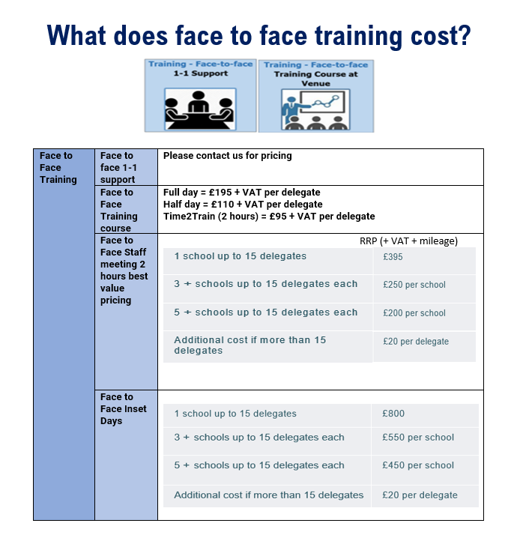

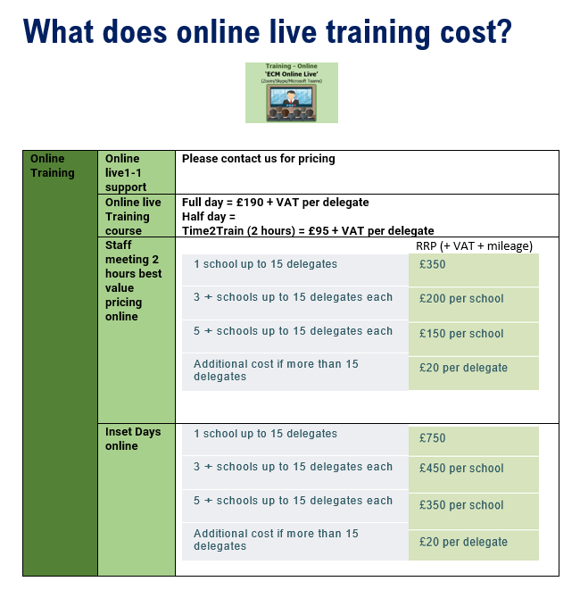
Bookings Form- Face to Face & Online Live

To make any bookings please visit our website (where you will find dates and venues), call us on 07401 990093, email bookings@ecm-educationconsultants.co.uk or complete the booking form and email to us (bookings@ecm-educationconsultants.co.uk)

School Name: | Contact Tel:
Head teacher’s name: | Email Address:

Booking Form  Training Course Titles |  |  |  | Number/ Names of delegates
 | FACE TO FACE  1-1 Support* | FACE TO FACE  Training Venue* | ECM  ONLINE  Live*
Name of ECM associate | Number of hours required | Contact email/ phone number to arrange online communication

What delegates have said about our Senior Leadership training:

“I attended the SES training at Markland Hill on Wed the 19th Sept. We got the Ofsted call on Mon this week for Tuesday! I’d just like to say thank you so much for packing in a really productive SES writing day. It stood up to Ofsted beautifully and was highly praised. Thanks for all that you do to improve our schools.”

“Can I just begin by saying how good the two days of training were at Parkfield from ECM on school self-evaluation and strategic development planning. It was some of the best training I have ever attended. I believe that part of the success was having the two days back to back as it really did enable us to stop and think.”

“Great personal support for us and our school. Time to work together and good examples to help us so we don’t have to re-invent the wheel”

What delegates have told us:
“EXCELLENT! Challenging topic made easy by clear delivery, extremely useful! “
“Always so informative. Always come away feeling like I am the most
up to date that I can be with my subject. Great ideas for Gap tasks that will
benefit the whole school and my developing role.”

“The knowledge and experience of the associates leading the training is without exception of a very high standard and they are invaluable in supporting our school”

“The support we have received from ECM has been key to the school’s rapid improvement and now ongoing successes.”

“It was enjoyable, well presented and there were lots of opportunities to share and gather ideas. Even better because the course leader knew what it was like for participants on the course. Great materials were provided for use back at school.”

“Very easy to understand, passionate, answered questions, put us at ease and made a hard subject understandable”

