SCHOOL LEADERSHIP PARTNER and ECM SERVICES 2023/24

ECM Education are pleased to bring to your attention our offer of services for 23-24.

We are now approaching our 13th year and continue to support primary and secondary individual schools, groups of schools and MATs across the North West and the UK, with a high quality programme of relevant and up to date services that give excellent value for money. As you plan for the year ahead, we hope you will consider our offer and join the many successful schools who have already benefitted from our trusted services.

|  |  |  |
| --- | --- | --- |
|  | Diagram  Description automatically generated with medium confidence | Diagram  Description automatically generated |
| Diagram  Description automatically generated | Diagram  Description automatically generated |  |
|  | Chart, bubble chart  Description automatically generated | Diagram  Description automatically generated |

## An ECM Leadership Partner can work alongside school leaders and staff to provide a wide range of bespoke guidance, support, coaching and training opportunities……….

ECM Leadership Partners will work with leaders to identify the school’s needs and implement strategies to improve school effectiveness and pupil outcomes.

ECM can work with schools to co-design a single consultancy day to address a specific need e.g., support with writing part of the school’s self-evaluation summary or can build a package of Leadership Partner days for the school across the year. The focus for each visit is based around the school’s identified needs and can include external validation of the school’s improvement work.

We can provide support in ways that suit you.

We offer:

* Full day support - 6 hours in school or 5 hours in school and a Note of Visit, recording strengths and areas for development
* Half day support in school - 3 hours
* We also offer a detailed report with your judgements validated as well as a shorter Note of Visit
* Our consultants can also support governors and headteachers in applying their appraisal systems effectively. Our consultants can support all staff members meeting your school's individual needs.
* We can provide INSET days, twilight sessions and staff meetings as well as reviews and SES writing support.
* We are keen to provide the support necessary for schools to provide the best outcomes for pupils.

Example report format



## ECM Leadership Partner schools already use ECM for Headteacher Performance Management. HTPM is available to all schools even if you are new to ECM or don’t use us as your Leadership Partner……..

We provide:  
Independent external advice for members of the governing board when completing the headteacher performance management process.

Our service (4 hours) includes:

· A focused programme which is based on your school’s needs   
· All paperwork and guidance material   
· Advice on the requirements for headteacher performance management   
· Support for using the correct professional standards   
· Ensuring that governors and headteachers are aware of their roles in the process   
· Support for governors in evaluating headteacher performance   
· Advice on setting objectives taking into account school data on performance as well as your self-evaluation   
· Completion of all documents following the formal process

# Evaluation of Overall School Effectiveness (EOSE) – Duration depends on the size of the school

3 days in total - 2 days in school (or equivalent), 8 hours each day, ½ day preparation & ½ day report writing for a one-form entry school

£2150 (+ VAT + mileage)

ECM trained consultants provide a completely objective perspective on your school or academy. This will be an appraisal, in partnership with your senior leadership team and as a result you will be confident about your schools’ strengths and areas for improvement.

Preparation

An ECM trained consultant will audit your school’s IDSR and ASP, self-evaluation (SES) and School Development plans, internal data and Ofsted reports. This leads to identified areas to investigate which are shared with the school.

ECM will then work alongside you in school for a full day (8 hours). Meeting with Headteacher / Principal, Governors, Senior leaders, Middle leaders, Teachers, Teaching assistants, Office staff, Pupils and Parents, completing activities such as observations of Teaching, evaluations of Pupils’ workbooks, learning walks, and School monitoring documents.

We will validate your school’s own judgements in assessing the effectiveness of leadership and management, the quality of education, personal development, behaviour and attitudes, and standards of the early years provision and offer advice on strategies to further improve your schools performance.   
  
This service provides CPD for school leaders on conducting self-evaluation activities and providing feedback for others and comes with a full written report on strengths and areas for improvement. The report and identified actions for improvement is divided into the following sections: Leadership & Management, Quality of Education, Personal Development, Behaviour and Attitudes, Early Years and Outcomes, and Overall Effectiveness.

# Curriculum Review (1 day)

1 day in school, preparation and Note of Visit £650 (+ VAT + mileage)

If you prefer a more detailed report + £200 to RRP = £850

ECM will provide a supported audit of your curriculum. From design and planning through to delivery, standards and assessment. We will work with your leaders interviewing staff and pupils, observing lessons, pupil books and curriculum planning. We will evaluate the strengths and areas for development needed at your school. Ofsted is placing a renewed focus on the Curriculum based on evidence of curriculum narrowing and teaching to the tests. We will help you make your curriculum a strength of your school by identifying your strengths and areas for improvement. This is a bespoke service to your school with preparation from your documentation and website and a report identifying what’s going well and where to go next.

# Pupil Premium Review (1 day)

1 day in school, preparation and Note of Visit

£650 (+ VAT + mileage)

If you prefer a more detailed report + £200 to RRP = £850

ECM consultants with a track record of improving outcomes for disadvantaged pupils will audit, review and report on the effectiveness and impact of your schools use of Pupil Premium Funding and how this is monitored by the school (SLT and governors). A detailed report will provide recommendations in terms of improving the use of PP money as well as confirming the schools strengths.

A Pupil Premium Review from ECM will:

review the effectiveness of your pupil premium strategy by observing practice in your school, interviewing school leaders including governors, evaluating teaching and pupil workbooks.

look at barriers to learning for your disadvantaged pupils and provide a detailed report that will provide recommendations for improving the use of Pupil Premium money and the processes used to do this.

# Early Years Review (1 day)

1 day in school, preparation and Note of Visit

£650 (+ VAT + mileage)

If you prefer a more detailed report + £200 to RRP = £850

ECM Education consultants offer a comprehensive approach to getting it right in early years. Schools with single reception classes to full units including children aged two can benefit from the range of bespoke support and development opportunities for leaders, teachers and practitioners.   
An Early Years review starts with a full triangulation of evidence relating to the impact of the full provision on the outcomes for children. The leadership aspect looks at the impact of leadership on the quality of teaching, learning and outcomes by making observations and considering children’s evidence and the use of assessment information. The evaluation includes a full day in school with preparation beforehand and written feedback afterwards. During the day in school, advisers will conduct a number of activities and will invite leaders to be part of the process.

In collaboration with your staff ECM will:

Consider the accuracy of self-evaluation activities and the quality of development and improvement planning

Scrutinise the effectiveness of the observation, assessment and planning cycle

Validate assessment by looking at a range of evidence

Observe, play with and talk to children

Discuss pedagogy, methodology and vision with leadership

Scrutinise performance information

Use the opportunity to coach and support staff and leaders  
·

A written record of feedback will allow leaders to celebrate strengths and develop areas for improvement

# SEND Review (1 day)

1 day in school, preparation and Note of Visit

£650 (+ VAT + mileage)

If you prefer a more detailed report + £200 to RRP = £850

This one-day review in your school alongside your SENCo will provide a critical and supportive process to evaluate the effectiveness of your SEND provision/co-ordination and identify areas of strengths and actions for development. Evidence will be collated in a written report to inform your school’s monitoring and evaluation of SEND provision.   
  
The ECM Review will:

Review the quality and impact of the following:

Securing self-evaluation of the quality of SEND provision

Interpretation of SEND data - identifying trends and processes for capturing an overview of achievement for SEND pupils

Create action plans with success criteria that is measurable and secures improvements through monitoring and evaluation strategies

Giving feedback to improve staff performance and coaching skills - working with governors and other stake holders

## Deep Dive into your chosen subject.

Supportive, collaborative and coaching school leaders through the process.

1 day in school.

Preparation, 5 hours in school, 1 hour note of visit –

£650 (+ VAT + mileage)

If you prefer a more detailed report + £200 to RRP = £850

Deep Dives available in:

English, Early reading and phonics, Maths, Science, History, Geography, D&T,

PE, Music, RE, Art,

Computing,

Languages.

ECM offers a supportive coaching approach through the Deep Dive process

Focusing on the 6 key areas identified by Ofsted. CURRICULUM, PEDAGOGY, ASSESSMENT, CULTURE, SYSTEMS, POLICY.

A typical day we can bespoke with you would include the following activities shadowed by you and your colleagues.

Review of the subject curriculum on website using an ECM aide memoire question sheet.

Initial conversation with HT discussing and agreeing agenda for the day and overviewing the quality of education in the deep dive subject

Interview with HT/curriculum lead on the quality of education overall and the chosen subject in particular using ECM aide memoire question sheets and the school’s curriculum documents, SEF judgements, SDP links and action plans.

Interview with subject leader on the quality of education in their subject. Including a book scrutiny.

Learning walk in the year groups agreed with HT

Pupil interviews with children from across the school

Interview with teachers seen teaching xxxx

Pulling together of main findings with HT, Curriculum lead and subject lead agreeing strengths and next steps

## For CEO’s, Executive Heads, Headteachers and Senior Leaders in Primary and Secondary Schools….

3 hrs in total

£400 + VAT

Supporting you to be prepared to describe and discuss the INTENT, IMPLEMENTATION, and IMPACT of your school curriculum.

Timetable- 3 hours in total

1 hour- preparation conducted by the ECM team member- website/ IDSR outcomes.

Curriculum Senior Leader Meeting- 2 x 45-minute meetings, plus 15 minute reflection opportunities and 15 minute summary.

## We can review your curriculum INTENT long term plans in each of the national curriculum subjects with a focus on…

the degree to which each subject is knowledge, (including vocabulary & concepts) and vocabulary focused and the degree to which it is both progressive and sequenced to your group end points. We can support you to evaluate if the curriculum INTENT plans in each subject area are representing high expectations and the degree to which they are inspection ready.

High expectations in each year group;

Progression and Sequencing;

Knowledge & Skill focus

School Context

A brief note of visit (NOV) will be written outlining key strengths and suggestions for further

development.

This activity will be completed remotely.

English - 2 hrs

Maths - 2 hrs

Science - 1.5 hrs

Foundation subjects - 1 hour per subject

2 hour - £235 + VAT

1.5 hours = £175 + VAT

1 hour - £120 + VAT

Example Offer 1- Curriculum INTENT Check

£650 + VAT (reduced rate offer)

English

Maths

Science

Foundation Subject (of your choice)

Foundation Subject (of your choice)

Example Offer 2- Curriculum INTENT Check

£650 + VAT (reduced rate offer)

6 x Foundation Subjects

Example Offer 3- Curriculum INTENT Check

English

Maths

3 x Foundation Subjects

## What is the purpose of coaching?

To enable you to be more productive, happy and empowered to make sustainable change in your life and work…

1 x 1hr session = £125

1x 1.5 hour session = £180

Package of 4 sessions= £700

For CEOs, Head teachers, Senior Leaders, Staff at all levels in schools.

What does coaching do and what are the benefits?

Focuses on you- it’s for you and about you.

What does coaching do and what are the benefits?

Focuses on you- it’s for you and about you.

Provides a trusting and confidential space to share your thoughts.

It helps you to help yourself- a coach listens and asks powerful questions to promote discussion.

Allows you to see things from different perspectives.

Provides an opportunity to work in partnership in an honest, supportive, respectful safe place and is focused on what you want to achieve.

Keeps the agenda ‘outcome’ focused- enabling you to make sustainable change by developing a plan.

Supports you to develop your knowledge base and skillset to apply newly developed strategies.

Why do people choose coaching?

There are many and varied reasons why people choose coaching to support them to find their own solutions. Examples include that they:

feel too busy;

feel their workload is too big;

need to prioritise;

have challenges in managing people or teams;

have a significant challenge/opportunity in work;

are at a career crossroads and want to consider the next step.

If you feel that any of this applies to you, we can help and support you through a coaching model.

What does a programme of coaching look like?

Online sessions;

An initial 20 minute scoping meeting to explore how coaching would work best for you;

Typically then 4 x 1.5 hour coaching sessions to explore your challenges and opportunities (this can be as many or as few sessions as you like).

## ECM can provide and arrange all your INSET Day and Staff Meeting needs. Choose from our full offer of CPD topics or request a bespoke INSET or Staff Meeting delivery. INSET and Staff Meetings can be delivered to small and larger groups, with clusters of schools joining up for shared CPD. As demand is usually around the same time as many other schools, it is advisable to book well in advance to ensure your booking and needs can be met…

**Some of our most popular INSET Day and Staff Meeting topics:**

Giving strong account for your subject

Deep Dives in all subjects

Ensure your subject curriculum intent is high quality and will stand up to inspection scrutiny

Further details and session titles can be found on our website.

## Schoot is a subscription based, online platform, designed to inspire successful educators through on-demand, high-quality training and opportunities for collaboration with other colleagues in primary, special and secondary school settings….

<https://schoot.co.uk/>

[Schoot training brochure](https://schoot.co.uk/wp-content/uploads/2023/01/Schoot-Training-Catalogue-2022-23-30Jan-1.pdf)

*Online training from Schoot has****transformed the way we approach professional development across our trust.*** *Staff have access to high quality, online learning that matches the needs of the trust, as well as the needs of individual schools. Staff feedback has been extremely positive with staff noting how the training is current, well resourced and informative and as a result supporting them as professionals to improve their own subject knowledge and pedagogy. The high level of engagement from all our teachers is testament to the offer that Schoot provide.*

*Liz Peacock*

*Trust Education Director, Vantage Academies Trust. September 2021*

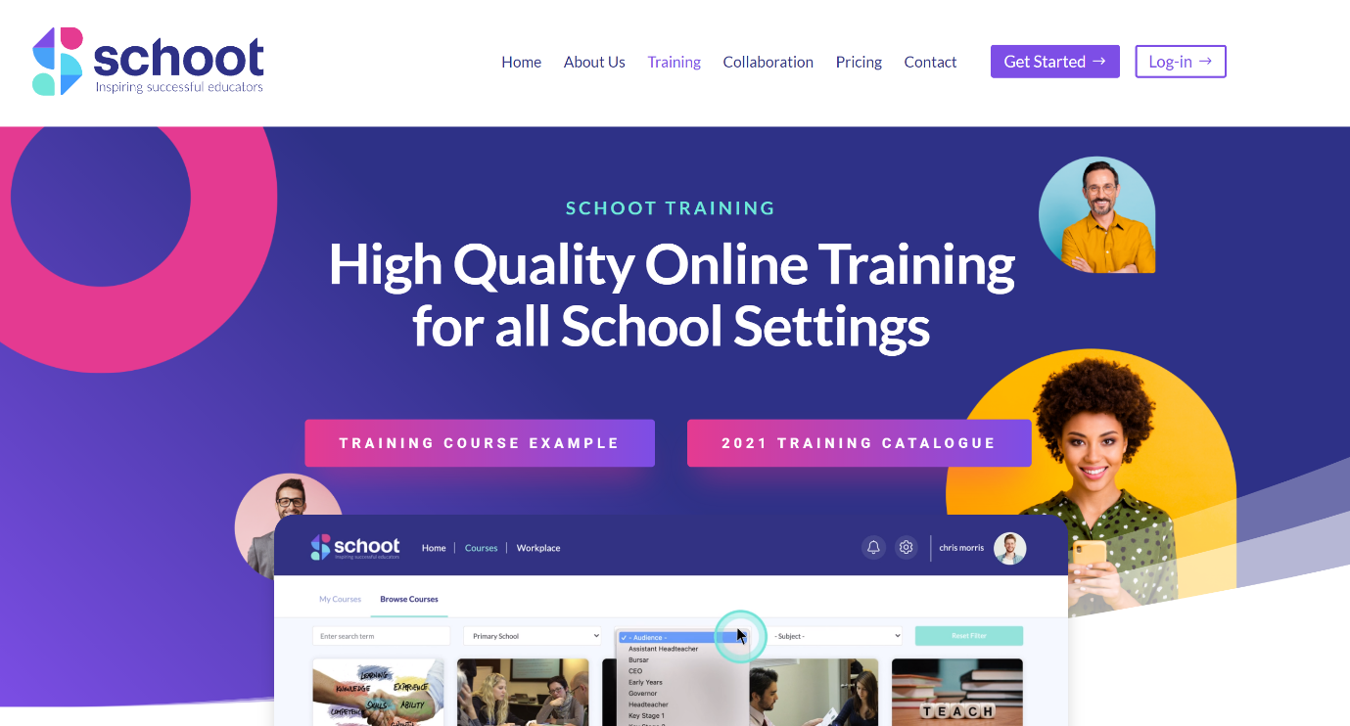

## Our contact details….

Call us on 0844 335 1022

Email [bookings@ecm-educationconsultants.co.uk](mailto:bookings@ecm-educationconsultants.co.uk)

Visit our website – <http://www.ecm-education.co.uk>