ECM Headteacher Performance Management

2023/24

Headteacher Performance Management 4 hour process
ECM Leadership Partner schools already use ECM for Headteacher Performance Management.
HTPM is available to all schools even if you are new to ECM or don’t use us as your Leadership Partner.
We provide:
Independent external advice for members of the governing board when completing the headteacher performance management process.
Our service includes:
· A focused programme which is based on your school’s needs
· All paperwork and guidance material
· Advice on the requirements for headteacher performance management
· Support for using the correct professional standards
· Ensuring that governors and headteachers are aware of their roles in the process
· Support for governors in evaluating headteacher performance
· Advice on setting objectives taking into account school data on performance as well as
your self-evaluation
· Completion of all documents following the formal process
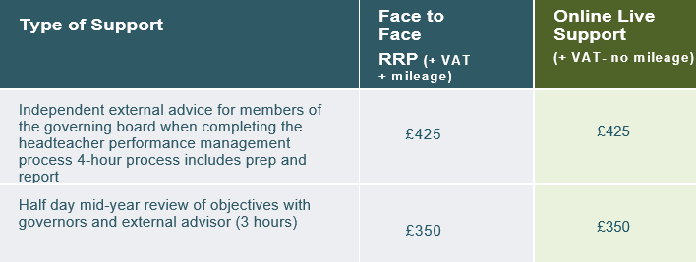
For further information or to request one of our services please contact us on the details below:
TEL: 07401 990093 or email bookings@ecm-educationconsultants.co.uk

